**Air Ticket Reservation System**

**Introduction**

The Air Ticket Reservation System is a significant step forward in travel technology, making it easier for both travelers and travel agencies to book flights. This report delves into the comprehensive system design of this innovative platform, shedding light on its architecture, functionalities, and the impact it brings to the aviation and travel industry. The significance provided by ATRS can be defined in four distinct points. They are:

* Enhanced convenience
* Greater choice
* Efficient management
* Improved revenue

**Objectives**

The primary objectives of Air Ticket Reservation System are:

* To provide a user-friendly and intuitive interface for travelers to conveniently search, compare, and book flight tickets.
* To maintain an accurate and real-time database of flight schedules, fares, and seat availability for various airlines.
* To automate the booking process, including passenger information capture, seat selection, payment processing, and e-ticket issuance.
* To offer secure and reliable data management, ensuring passenger privacy and financial information protection.
* To enable integration with airline systems and global distribution networks (GDS) for seamless data exchange and transaction processing.

**Application Overview**

The Air Ticket Reservation System can include the following key features:

* Flight Search: Travelers can specify travel dates, destinations, preferred airlines, and budget constraints to find suitable flights.
* Booking Management: Travelers can select flights, seats, and additional services, confirm their booking, and make secure payments through integrated payment gateways.
* Passenger Information Management: Passengers can create accounts, store traveler details, manage bookings, and receive updates via email or SMS notifications.
* Airline Dashboard: Airlines can access a dedicated dashboard to view bookings, manage passenger information, monitor inventory, and generate reports.

**Problem statement**

* Manual booking processes are time-consuming and prone to errors.
* Increasing air travel demands necessitate an efficient and automated reservation system.
* Difficulty in managing and coordinating flight bookings without a centralized system.
* Lack of real-time information accessibility for both travelers and travel agencies.
* Growing complexities in scheduling and managing a large volume of flight reservations.
* Inadequate organization of flight data, leading to confusion and potential disruptions.
* Rising customer expectations for seamless and user-friendly booking experiences.
* Inefficient utilization of resources in traditional booking methods.
* Inability to adapt quickly to changing travel regulations and industry dynamics.
* Increased competition in the travel sector, requiring streamlined and competitive services.

**Requirement and Feasibility analysis**

The requirements that the purposed system must have include:

* Intelligent Booking Engine:
* Develop a user-friendly interface with an advanced search algorithm for real-time flight information.
* Enable secure and seamless ticket booking, integrating with airline databases and payment gateways.
* Enhanced User Experience:
* Implement personalization features for user preferences and tailored recommendations.
* Ensure responsive design, automated notifications, and straightforward cancellation/refund processes.
* Security and Compliance:
* Incorporate robust security measures for user data and transactions.
* Adhere to aviation regulations, data protection laws, and industry standards.

For the feasibility analysis, we take a look at three major aspects, technical, financial and operational as per the recommendation from the requirement analysis.

* Technical Viability:
* Evaluate compatibility with existing technologies and integration capabilities.
* Assess technical requirements and potential challenges in system development.
* Financial Analysis:
* Estimate costs for software, hardware, and personnel.
* Analyze return on investment (ROI) and long-term financial sustainability.
* Operational Alignment:
* Assess how well the system integrates into existing operational processes.
* Evaluate ease of deployment and impact on day-to-day activities

**Design**

**Gnatt Chart**

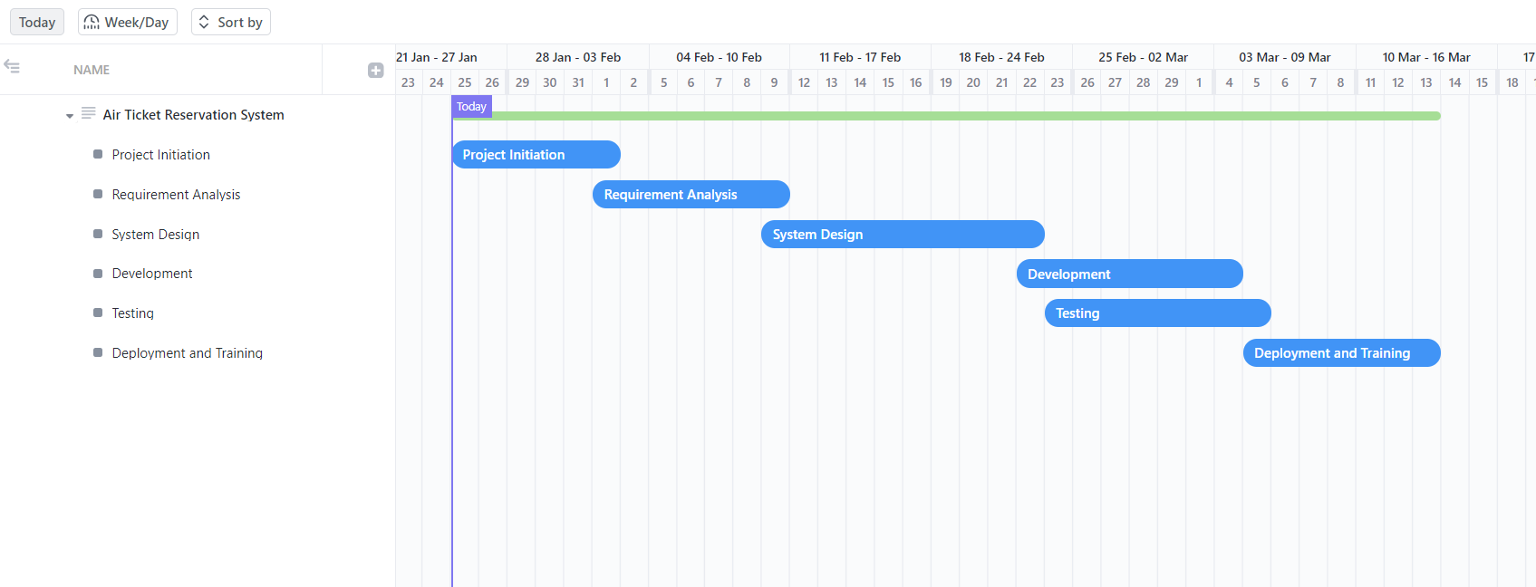

**Class diagram**

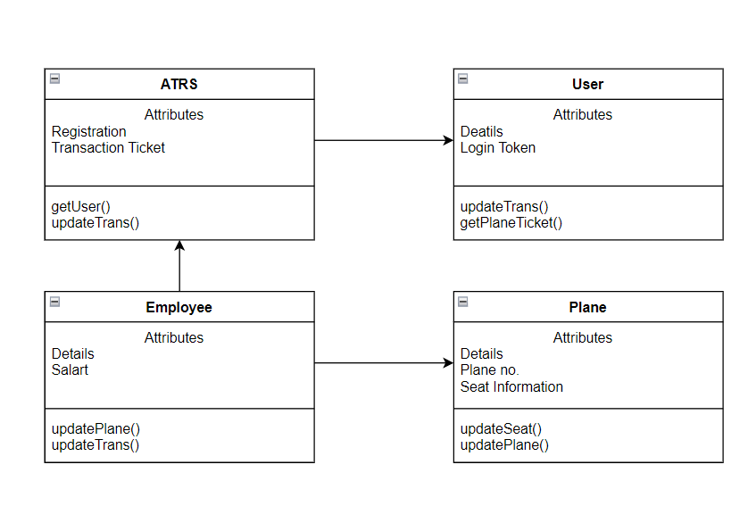

**Use Case Diagram**

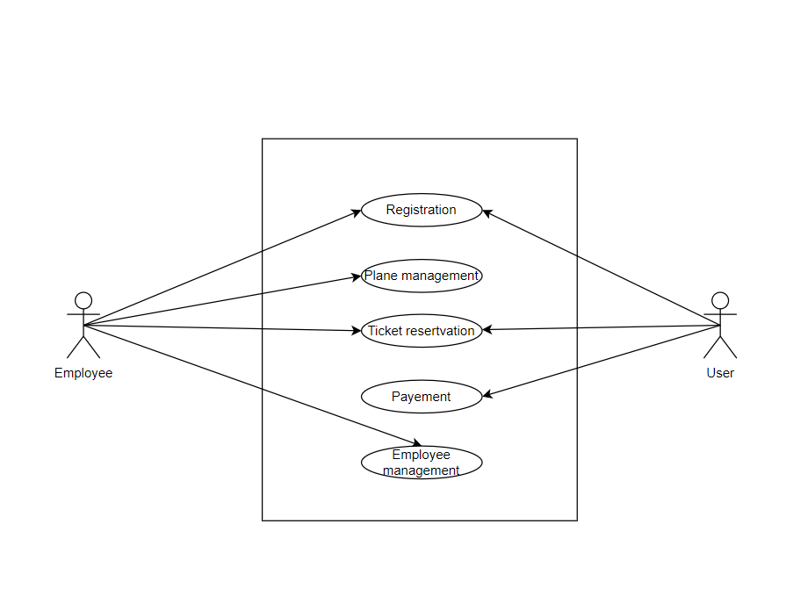

**Activity Diagram**

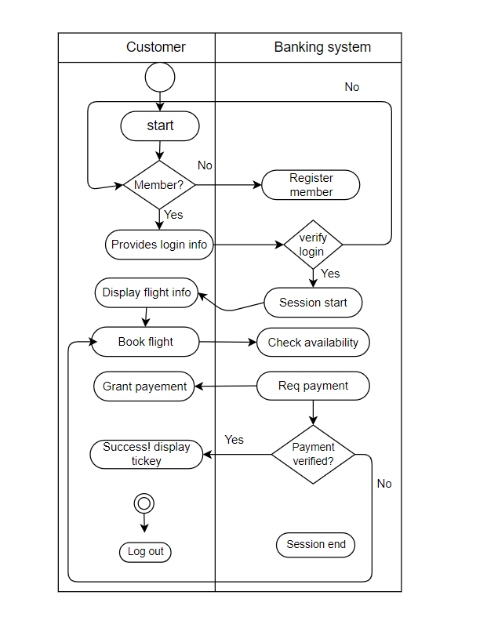

**Data Flow Diagram Level 0**

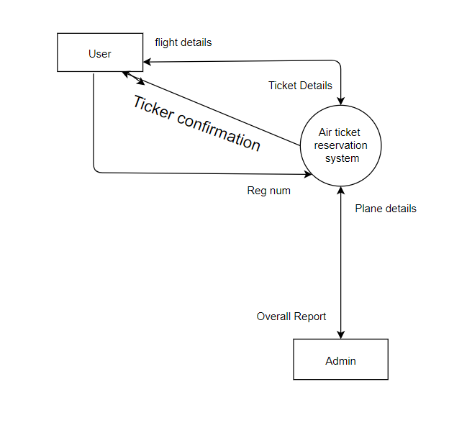

**Data Flow Diagram Level 1**

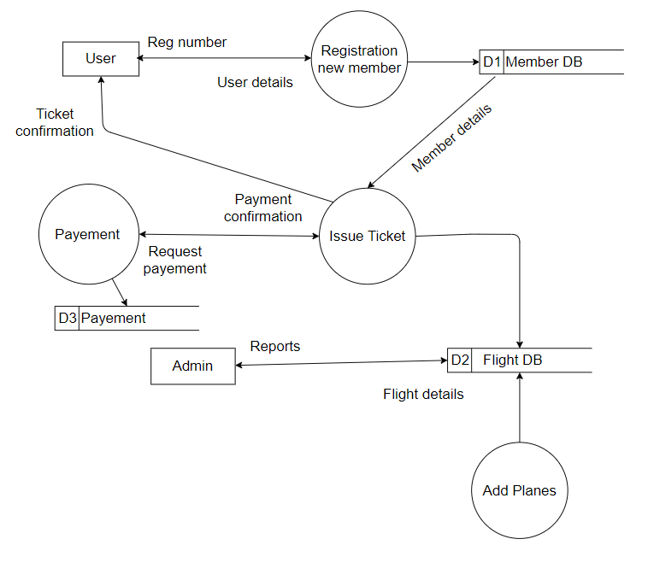

**Entity Relationship Diagram**

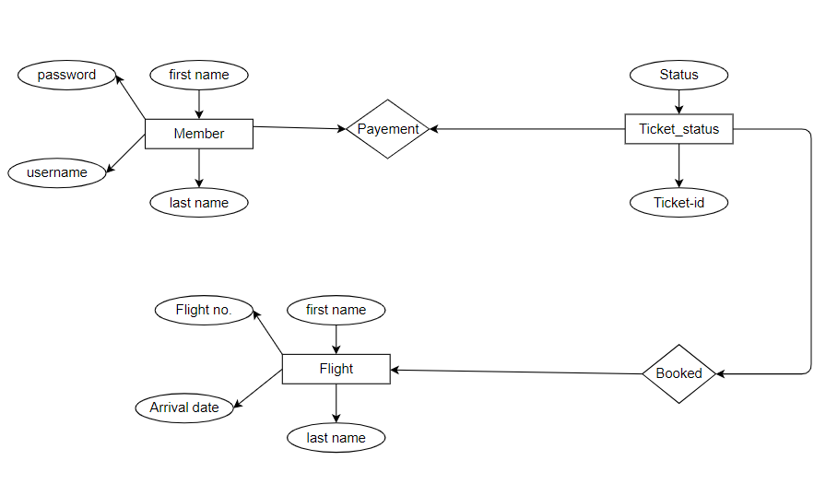

**Conclusion**

In summary, the creation process of the Air Ticket Reservation System (ATRS) stands as a pivotal achievement in revolutionizing the travel industry. Following a systematic approach, encompassing rigorous system analysis and feasibility assessments, the ATRS emerges as a comprehensive solution to the challenges faced by travelers and travel agencies. By addressing issues related to manual processes, real-time information access, and the increasing complexities of flight reservations, the ATRS aims to enhance operational efficiency and provide a seamless booking experience for users.

Our unwavering dedication to aligning the system with the needs of both travelers and industry stakeholders ensures its potential for widespread adoption and success. Looking ahead, the forthcoming stages will concentrate on realizing our vision of a technologically advanced and user-friendly air ticket reservation landscape. These efforts are aimed at achieving greater efficiency, accessibility, and a customer-centric approach to air travel management. Future reports will delve into the intricate details of the ATRS's design, implementation, and its transformative impact on the aviation and travel industry, marking the beginning of a new era in streamlined and customer-focused air ticket reservation systems.

**Online Banking System**

**Introduction**

The development of the Online Banking System represents a groundbreaking advancement in financial technology, offering a streamlined and secure platform for users to manage their banking activities. This report delves into the comprehensive system design of this innovative platform, shedding light on its architecture, functionalities, and the transformative impact it brings to the banking and financial industry. The significance provided by OBS can be defined in four distinct points. They are:

* Enhanced Accessibility
* Increased Financial Control
* Efficient Transaction Management
* Enhanced Security

**Objectives**

The primary objectives of the Online Banking System are:

* To provide a user-friendly and secure interface for account holders to conveniently manage their finances, including fund transfers, bill payments, and account monitoring.
* To maintain an accurate and real-time database of account balances, transaction histories, and other financial information.
* To automate banking processes, including fund transfers, bill payments, account updates, and e-statement generation.
* To offer robust security features, ensuring the privacy and protection of customer information and financial transactions.
* To enable integration with banking networks, payment gateways, and financial institutions for seamless data exchange and transaction processing.

**Application Overview**

The Online Banking System can include the following key features:

* Account Management: Users can view account balances, transaction histories, and manage personal information securely.
* Fund Transfer: Customers can transfer funds between accounts, both internally and externally, with ease.
* Bill Payment: The system facilitates secure bill payments, automated scheduling, and transaction tracking.
* Alerts and Notifications: Users receive real-time notifications for account activities, ensuring timely awareness of transactions.
* Security Features: Multi-factor authentication, encryption, and secure login processes enhance the overall security of the system.

**Problem Statement**

* Manual banking processes are time-consuming and susceptible to errors.
* Increasing demands for online financial services necessitate an efficient and secure banking system.
* Difficulty in managing and coordinating financial transactions without a centralized online platform.
* Lack of real-time information accessibility for account holders and financial institutions.
* Growing complexities in financial activities, requiring a user-friendly and technologically advanced solution.
* Inadequate organization of financial data, leading to confusion and potential security risks.
* Rising customer expectations for seamless and secure online banking experiences.
* Inefficient utilization of resources in traditional banking methods.
* Inability to adapt quickly to changing financial regulations and industry dynamics.
* Increased competition in the financial sector, requiring streamlined and competitive online banking services.

**Requirement and Feasibility Analysis**

The requirements that the proposed system must have include:

* Intelligent Transaction Engine:
  + Develop a user-friendly interface with advanced transaction capabilities for real-time financial information.
  + Enable secure and seamless fund transfers, integrating with banking databases and payment gateways.
* Enhanced User Experience:
  + Implement personalization features for user preferences and tailored financial recommendations.
  + Ensure a responsive design, automated notifications, and straightforward dispute resolution processes.
* Security and Compliance:
  + Incorporate robust security measures for user data and financial transactions.
  + Adhere to financial regulations, data protection laws, and industry standards.

For the feasibility analysis, we examine three major aspects: technical, financial, and operational, as per the recommendations from the requirement analysis.

* Technical Viability:
  + Evaluate compatibility with existing technologies and integration capabilities.
  + Assess technical requirements and potential challenges in system development.
* Financial Analysis:
  + Estimate costs for software, hardware, and personnel.
  + Analyze return on investment (ROI) and long-term financial sustainability.
* Operational Alignment:
  + Assess how well the system integrates into existing operational processes.
  + Evaluate ease of deployment and impact on day-to-day banking activities.Top of Form

**Design**

**Gnatt Chart**

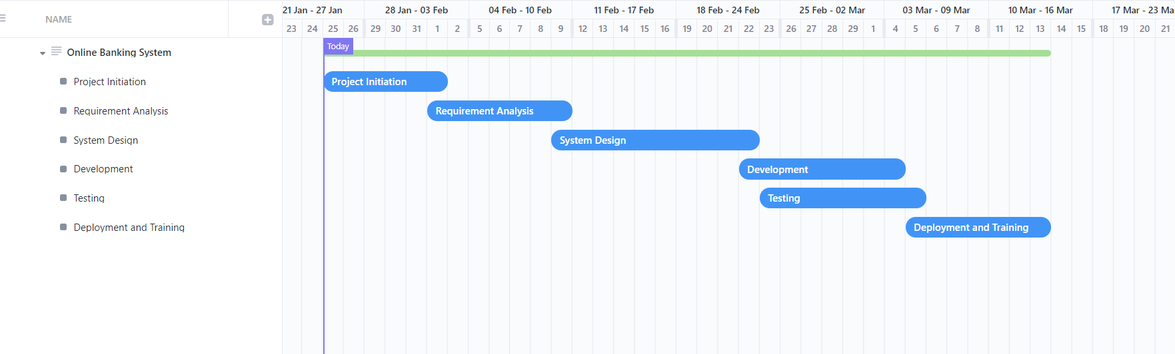

**Class diagram**

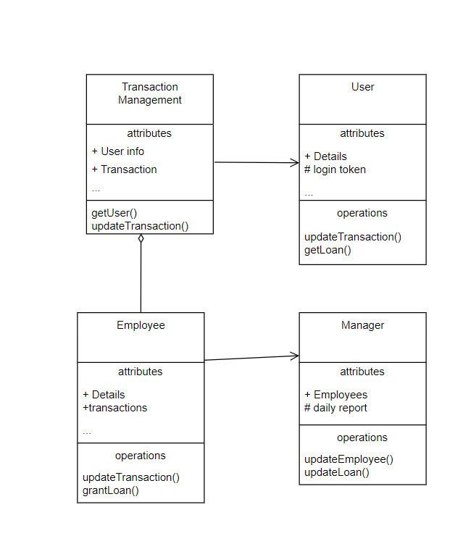

**Use Case Diagram**

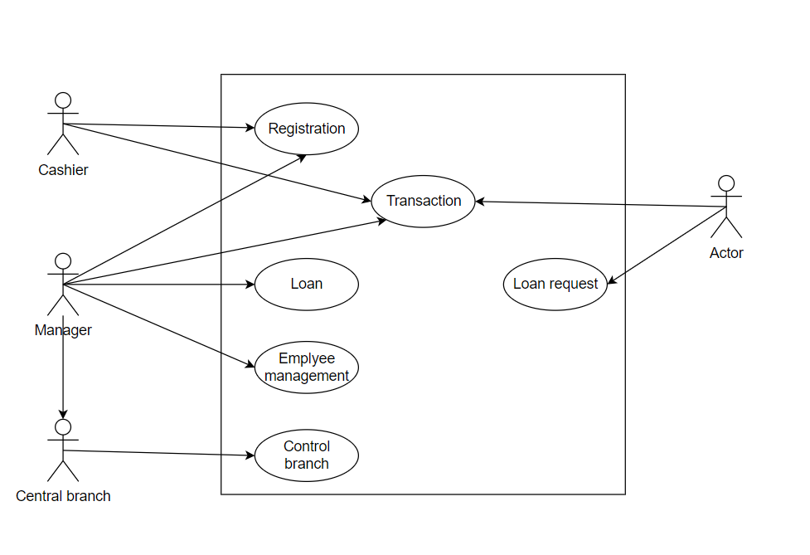

**Activity Diagram**

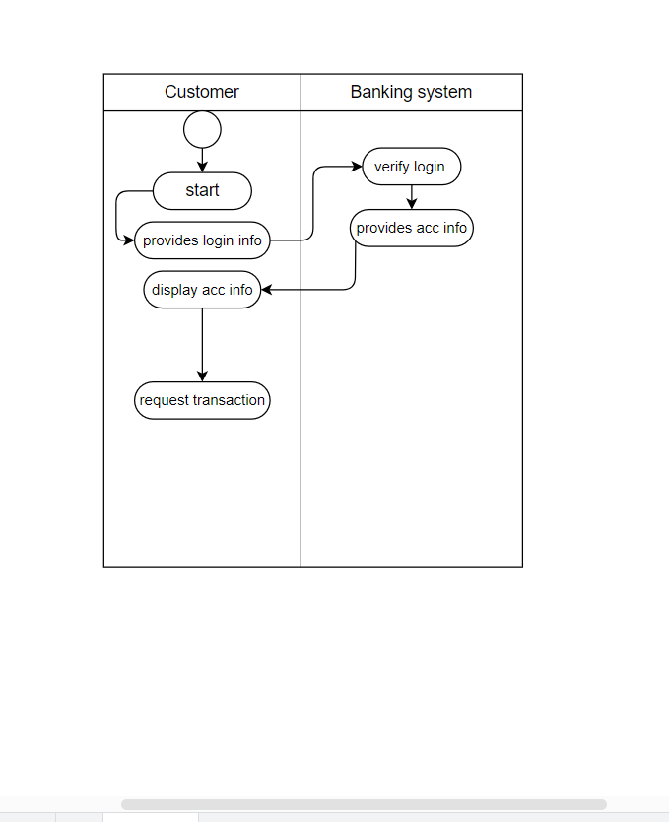

**Data Flow Diagram Level 0**

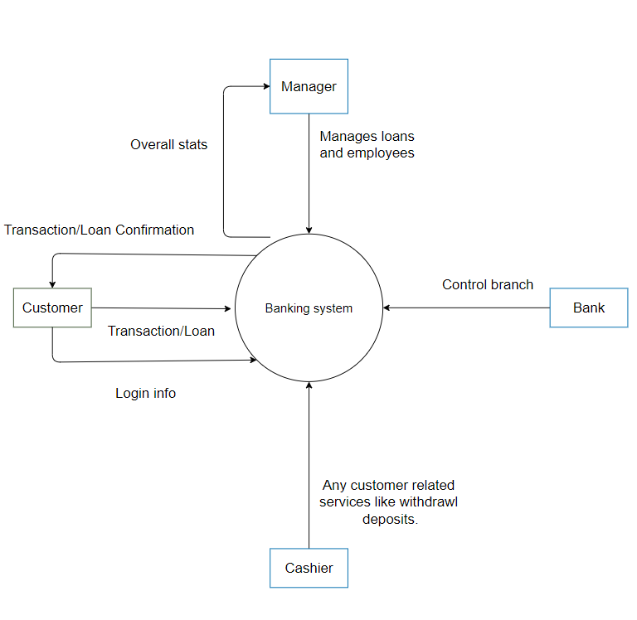

**Data Flow Diagram Level 1**

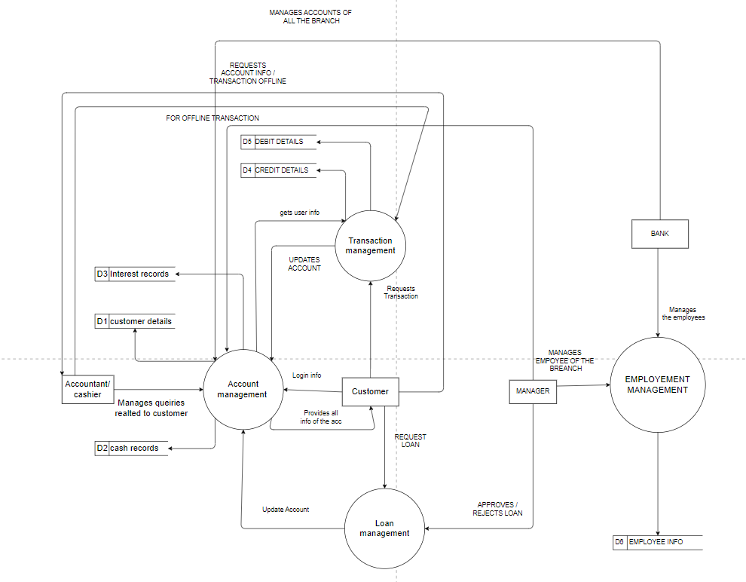

**Entity Relationship Diagram**

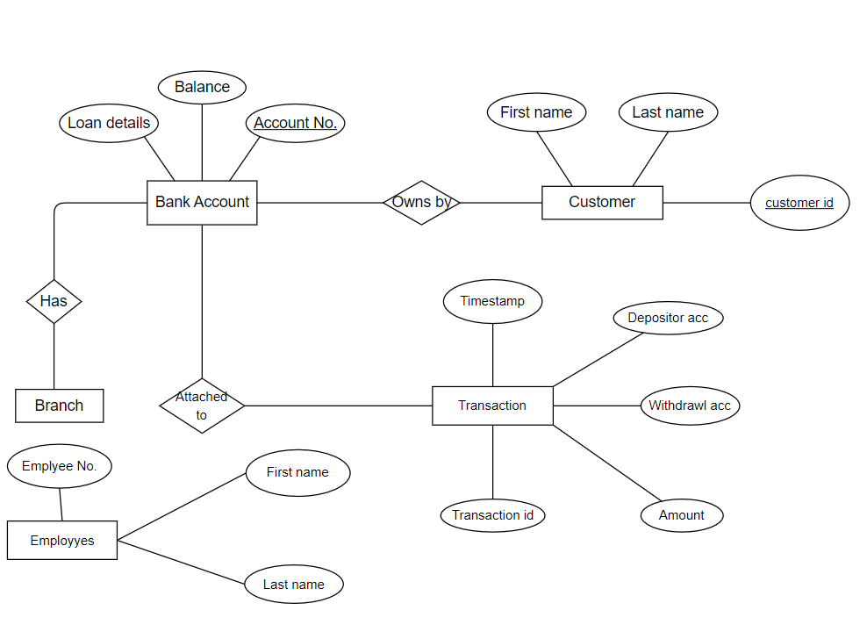

**Conclusion**

In conclusion, the creation process of the Online Banking System (OBS) represents a landmark achievement in reshaping the landscape of financial services. Fueled by a systematic approach, incorporating thorough system analysis and feasibility assessments, the OBS emerges as a comprehensive solution to the challenges faced by both financial institutions and users. By addressing issues related to manual banking processes, real-time information accessibility, and the growing complexities of financial transactions, the OBS aims to enhance operational efficiency and provide a secure and seamless banking experience for users.

Our unwavering commitment to aligning the system with the needs of account holders and financial stakeholders ensures its potential for widespread adoption and success. Looking ahead, the forthcoming stages will concentrate on realizing our vision of a technologically advanced and user-friendly online banking platform. These efforts are aimed at achieving greater efficiency, accessibility, and a customer-centric approach to financial management. Future reports will delve into the intricate details of the OBS's design, implementation, and its transformative impact on the banking and financial industry, marking the beginning of a new era in streamlined and customer-focused online banking systems.